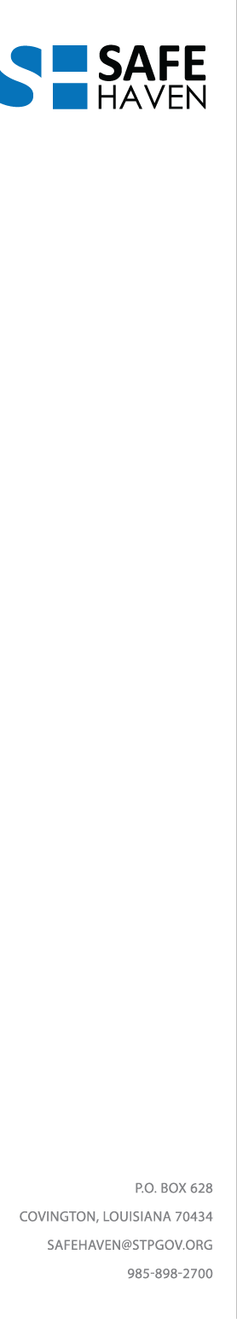

Safe Haven Advisory Board meeting

Monday, September 11, 2017, 11:00AM

1. Meeting called to order, Kelly Rabalais
2. Roll call, quorum established, Adele
3. Approval of minutes, June 2017
4. Safe Haven update and overview, June- September 2017, Kelly Rabalais
5. Facility plan update
6. Safe Haven Foundation planning
7. RFQ for Policies and Procedure Manual
8. RFP for Operator, funding options explored
9. Safe Haven Committee reports
10. Jail Diversion, Judge Peter Garcia
11. Healthcare, Dr. Charles Preston and Richard Kramer
    1. EMS participation update
12. Training and Education, Major Wharton Muller, Nick Richard
    1. Update on Deputy Crisis Unit
13. Other business
14. Meeting adjourned

Safe Haven Quarterly meetings, 2017

December 11, 11AM

Please go to the STP Safe Haven website [www.safehavenstp.org](http://www.safehaven.stp.org) to sign up for meeting notifications and announcements.